Project Design Phase-II

Data Flow Diagram & User Stories

|  |  |
| --- | --- |
| Date | 13 October 2022 |
| Team ID | **PNT2022TMID51918** |
| Project Name | Project – Personal Expense Tracker |
| Maximum Marks | 4 Marks |

# Data Flow Diagrams:

A Data Flow Diagram (DFD) is a traditional visual representation of the information flows within a system. A neat and clear DFD can depict the right amount of the system requirement graphically. It shows how data enters and leaves the system, what changes the information, and where data is stored.

Example: DFD Level 0 (Industry Standard)

# Example: [(Simplified)](https://developer.ibm.com/patterns/visualize-unstructured-text/)

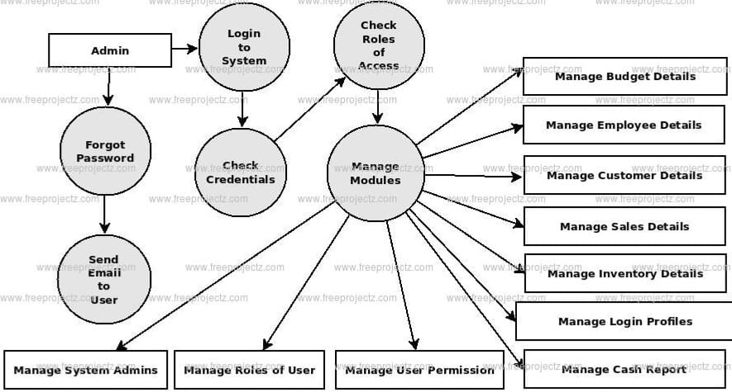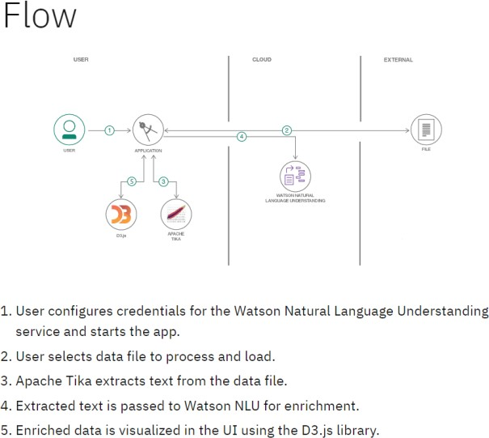

**Data flow diagram for Customer Care Registry:**

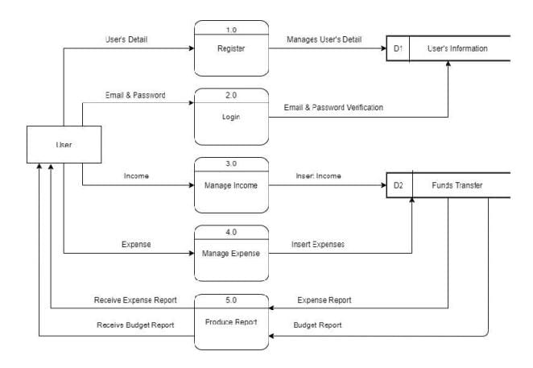

**User Stories**

|  |  |  |  |  |  |  |
| --- | --- | --- | --- | --- | --- | --- |
| **User Type** | **Functional**  **Requirement (Epic)** | **User Story Number** | **User Story / Task** | **Acceptance criteria** | **Priority** | **Release** |
| User | Registration | USN-1 | As a user, I can register for the application by entering my email, password, and confirming my password. | I can access my account / dashboard | High | Sprint-1 |
|  | Login | USN-2 | As a user, I can login to the application by entering correct email and password | I can access my account / dashboard | High | Sprint-1 |
|  | Dashboard | USN-3 | As a user, I can see all the expenses raised by me and lot more | I get all the info needed in my dashboard | High | Sprint-1 |
|  | Amount creation | USN-4 | As a user, I can create a new expense with the detailed description of my query | I can ask my query | High | Sprint-2 |
|  | Address Column | USN-5 | As a user, I can have conversations with the assigned agent and get my queries clarified | My queries are clarified | High | Sprint-3 |
|  | Forgot password | USN-6 | As a user, I can reset my password by this option in case I forgot my old password | I get access to my account again | Medium | Sprint-4 |
|  | Expenses details | USN-7 | As a user, I can see the current status of my expenses | I get better  understanding | Medium | Sprint-4 |
| Agent  (Web user) | Login | USN-1 | As an agent, I can login to the application by entering correct email and password | I can access my account / dashboard | High | Sprint-3 |
|  | Dashboard | USN-2 | As an agent, I can see all the expenses  assigned to me by the admin | I can see the expenses to  which I could answer | High | Sprint-3 |
|  | Address Column | USN-3 | As an agent, I get to have conversations with the customer and clear his/her queries | I can clarify the issues | High | Sprint-3 |
|  | Forgot Password | USN-4 | As a agent, I can reset my password by this option in case I forgot my old password | I get access to my account again6 | Medium | Sprint-4 |
| Admin  (Web user) | Login | USN-1 | As an admin, I can login to the application by entering correct email and password | I can access my account / dashboard | High | Sprint-1 |
|  | Dashboard | USN-2 | As an admin, I can see all the expenses  raised in the entire system and lot more | I can assign agents by seeing those tickets | High | Sprint-1 |
|  | Agent creation | USN-3 | As an admin, I can create an agent for clarifying the user’s queries | I can create agents | High | Sprint-2 |
|  | Assigning agent | USN-4 | As an admin, I can assign an agent for each ticket created by the user | Enables agent to clarify  the queries | High | Sprint-2 |
|  | Forgot password | USN-4 | As an admin, I can reset my password by this option in case I forgot my old password | I get access to my account again | Medium | Sprint-4 |